**PACKAGE MANAGEMENT YUM REPO**

**SERVER SIDE**

**Configuring Local Yum Repository:**

* Check whether the iso file is attached to the system by lsblk command.

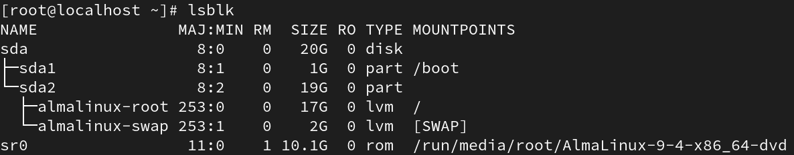

* Make a directory in **mkdir -p /var/ftp/pub/AppStream**



* Make a Directory in **mkdir /var/ftp/pub/BaseOS**



* Copy the directory from **/run/media/root/CentOS-Stream-9-BaseOS-x86_64/AppStream/Packages** to **/var/ftp/pub/AppStream**

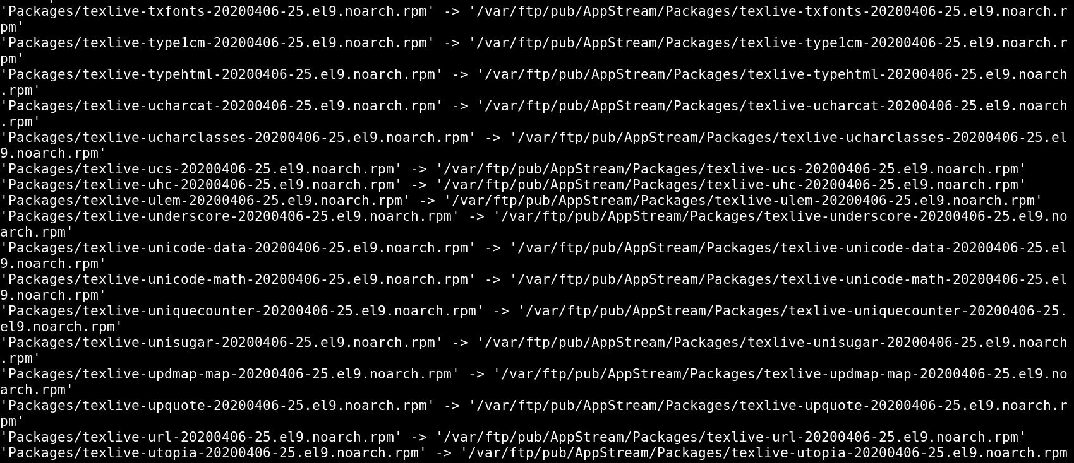

* Same as to BaseOS **/run/media/root/ CentOS-Stream-9-BaseOS-x86_64/BaseOS/Packages** to **/var/ftp/pub/BaseOS**

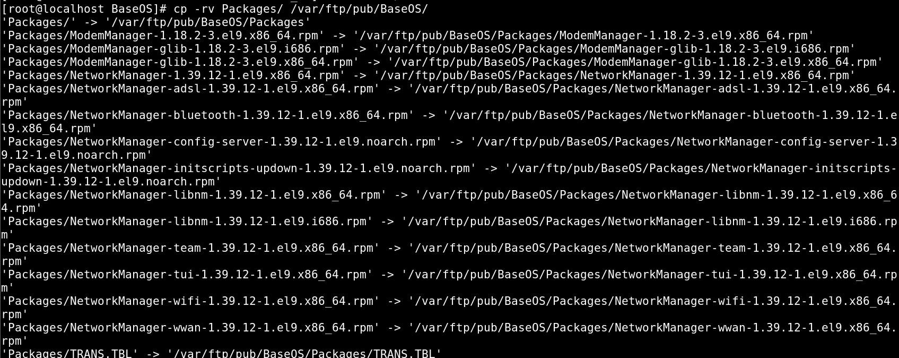

* Check whether the yum installed or not, if it not installed then install it using **rpm -ivh createrepo_c-libs-0.17.7-4.el9.x86_64**

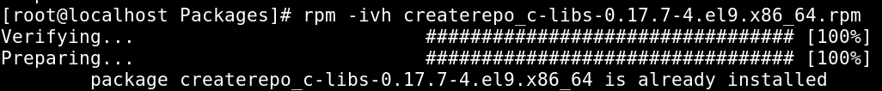

* Once Createrepo Command In Available Then Create Repository
* **createrepo -v /var/ftp/pub/AppStream/Packages/**

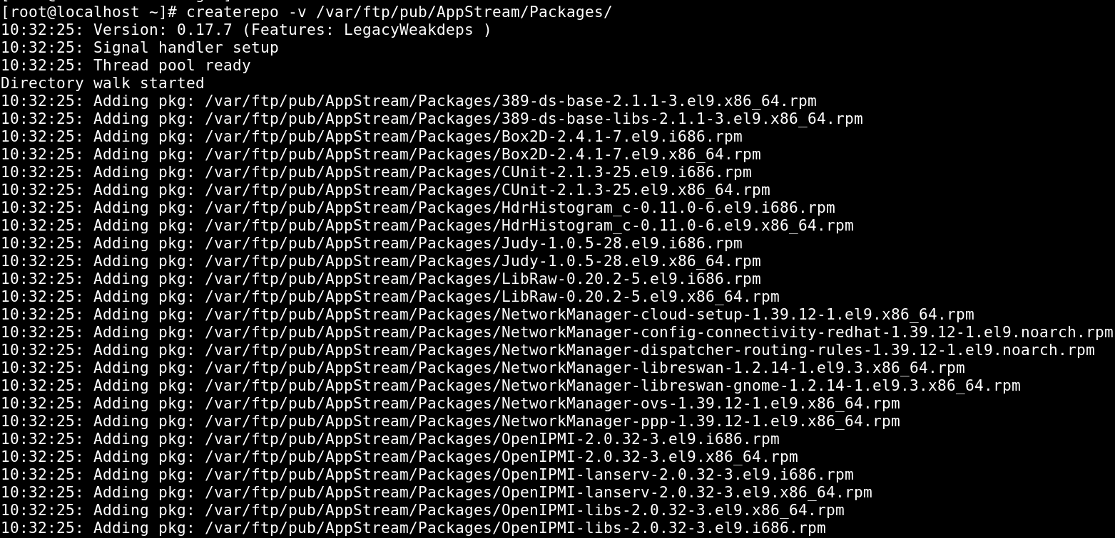

* **createrepo -v /var/ftp/pub/BaseOS/Packages/**

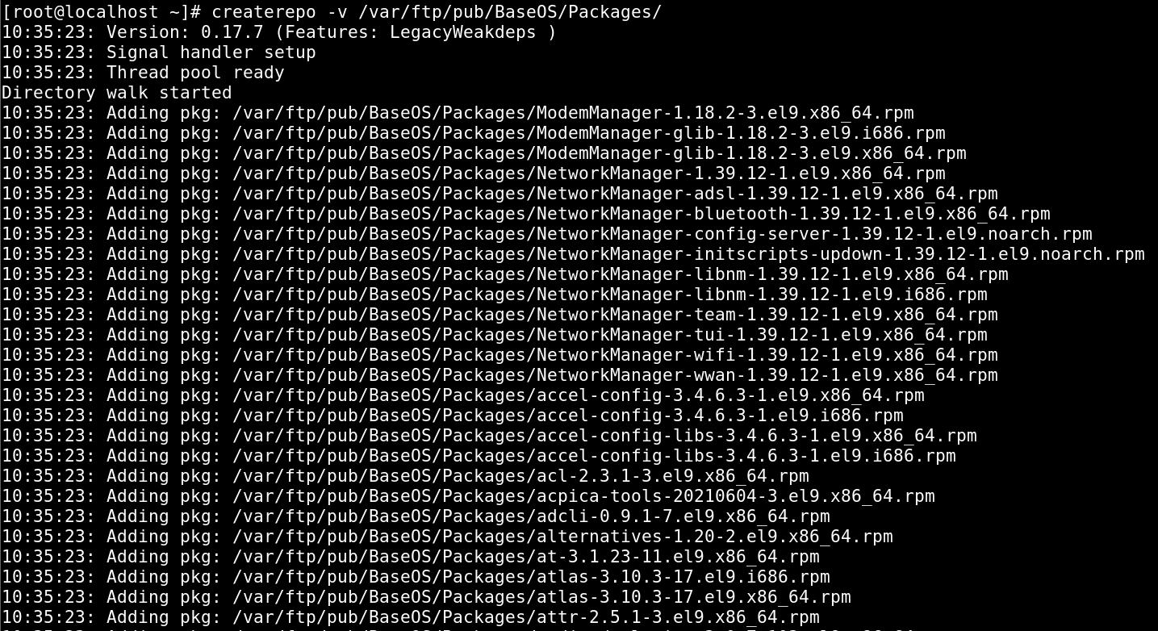

* Create the repository configuration file in **“/etc/yum.repos.d”** directory and make sure it has the **“.repo”** extension. And move the other repo files to another directory.

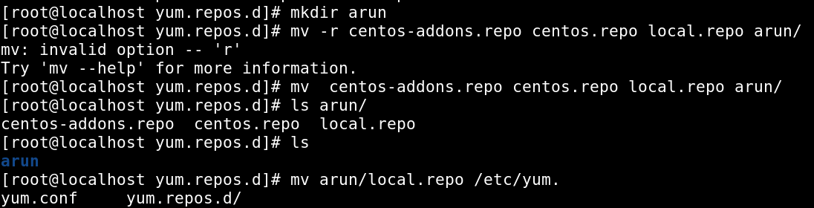

* Vi local. repo

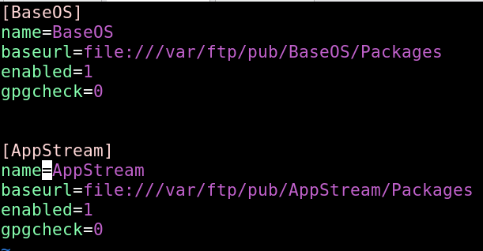

* Confirm the repository has been configured.
* **yum repolist list all**



* **yum clean all**



* **yum install nfs-utils-coreos.x86_64**

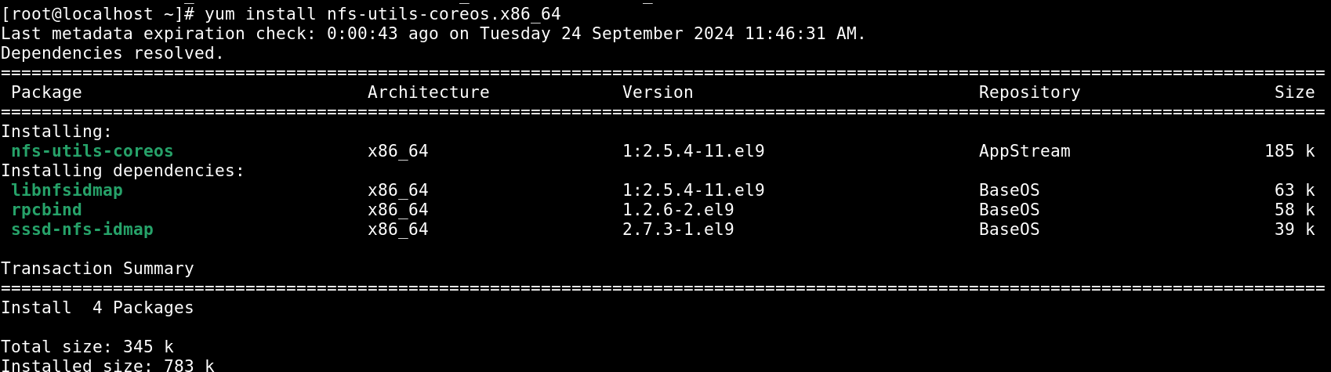

**IF IT IS LOCATED IN THE FTP SERVER**

**Follow the given instruction given below:**

* **Install vsftpd**

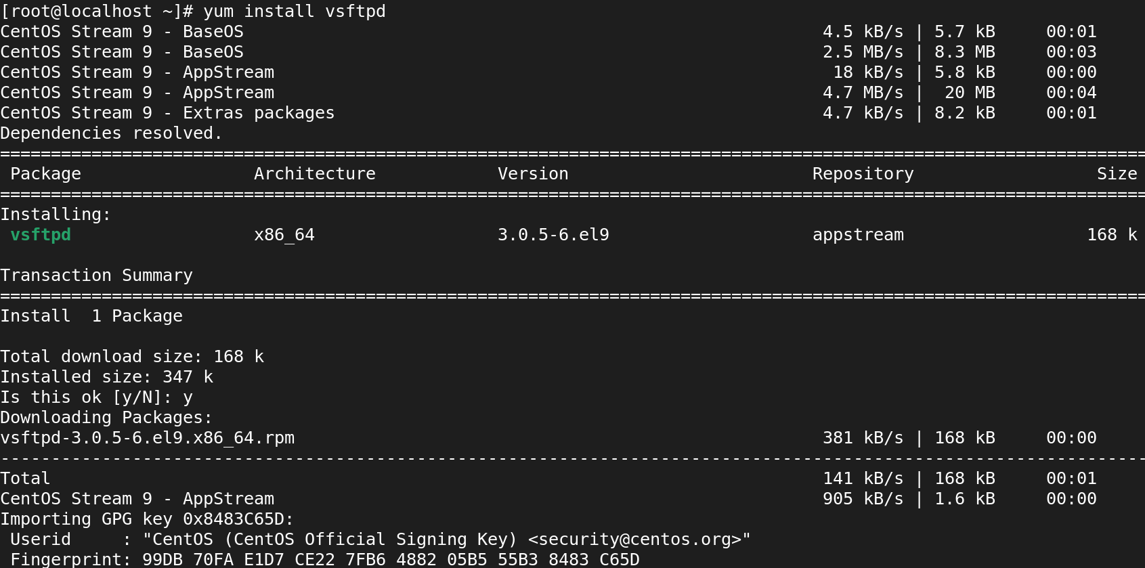

* **Disabling Firewall**

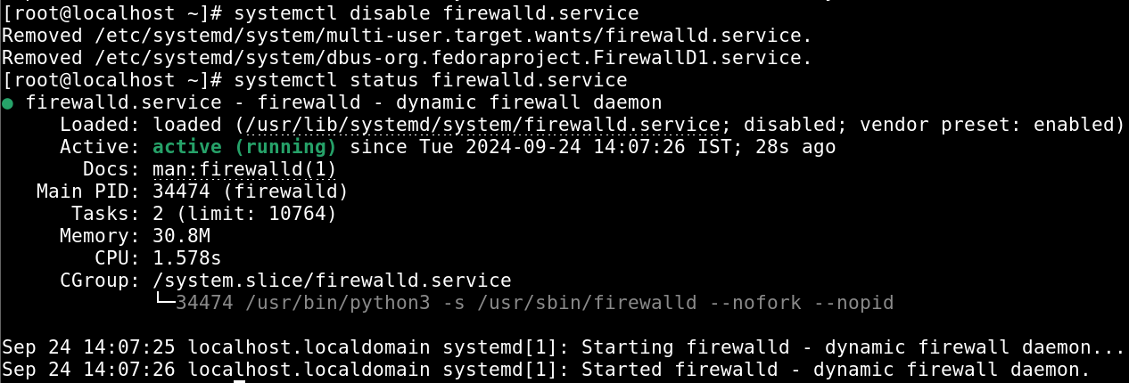

* **Enabling VSFTPD services**

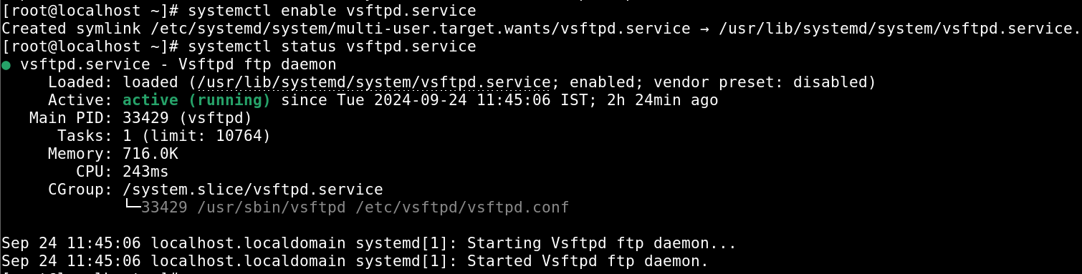

* **Disabling SELINUX**
* **Vi /etc/sysconfig/selinux**

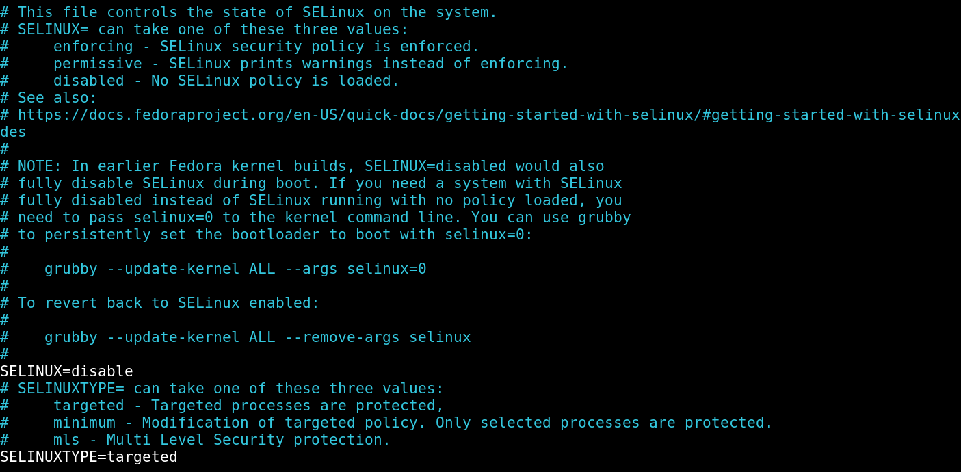

* **Gentenforce:**

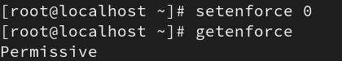

**ENABLING ANONYMOUS:**

* **Vi /etc/vsftpd/vsftpd.conf**

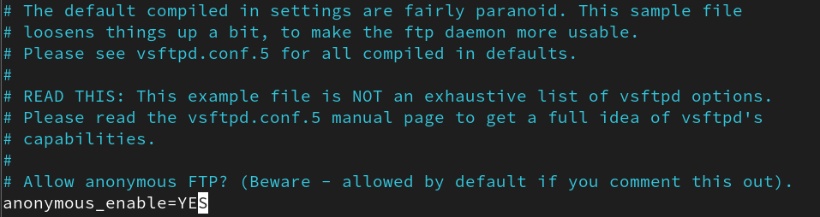

**RESTARTING VSFTPD.SERVICE:**



**CONFIGURING IP ADDRESS OF SERVER:**

* **ifconfig**

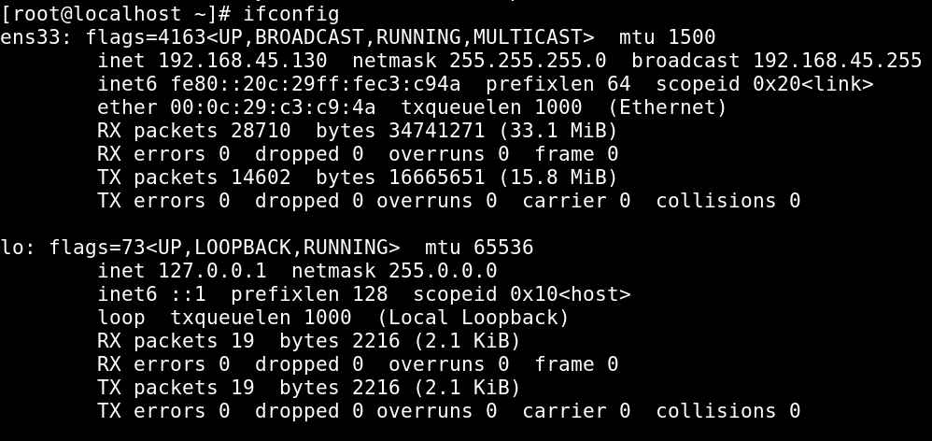

**CLIENT SIDE**

* **Change the directory:**
* cd /etc/yum.repos.d

**Move the files to the another directory which is in the config directory.**

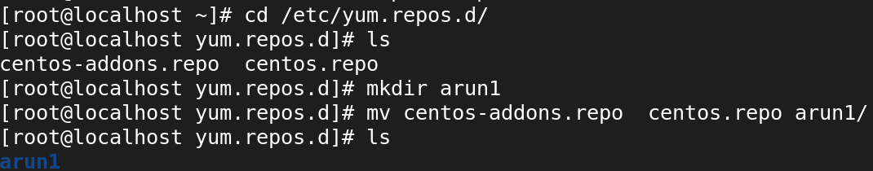

* **CREATING A NEW CONFIG FILE**
* vi ftplocal.repo

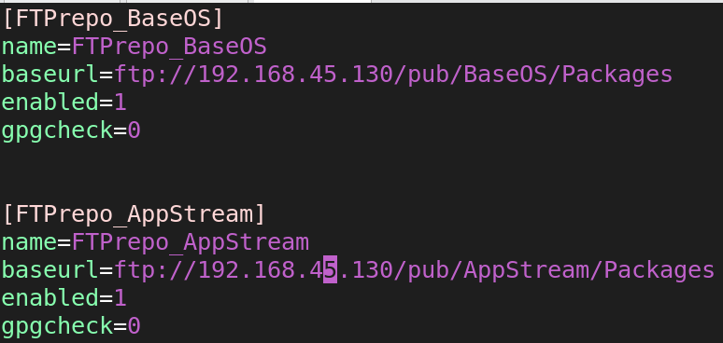

* yum clean all



* yum repolist all



**Without internet, should install the packages**

* yum install core-utils

